5 August, 2026
Todays topic –
- Validation rules
- Regex
Validation rules
- Write a validation rule to make last name mandatory
- Mandatory:
- 1. Meta data level
- 2. Validation rules
- 3. Page layouts
- 4. Apex
- Today we will be doing it from validation rules

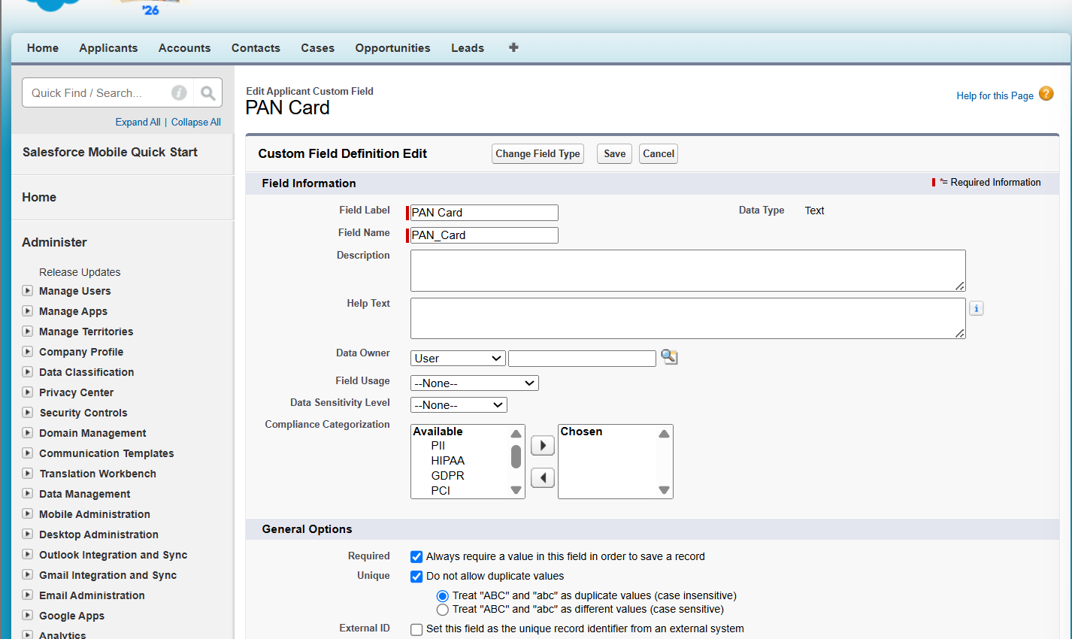

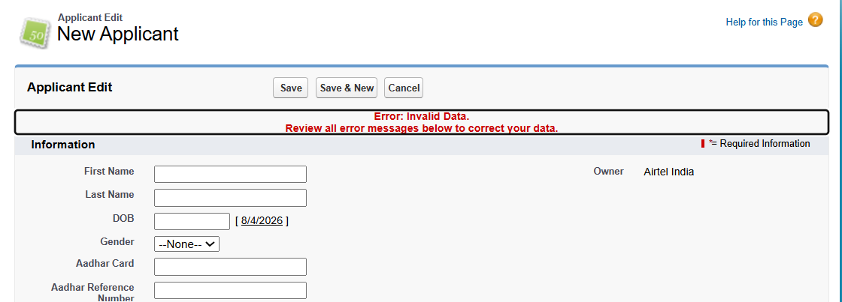

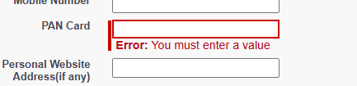

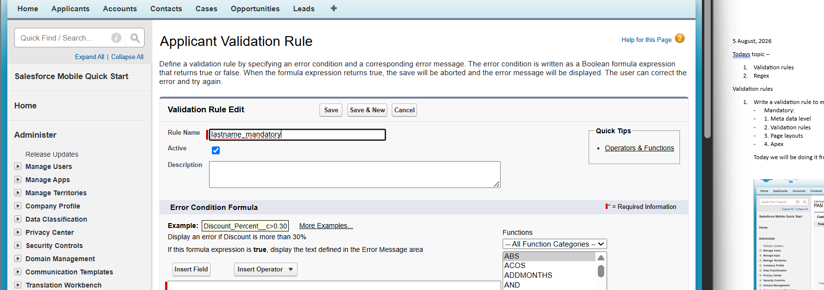
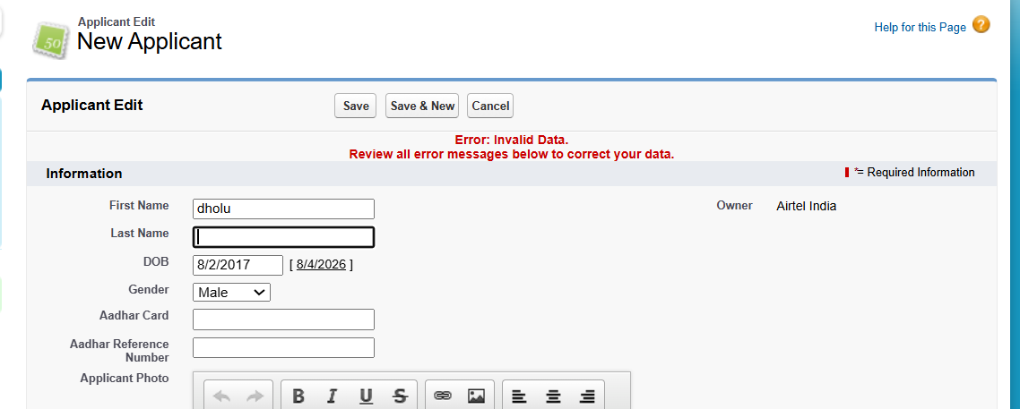

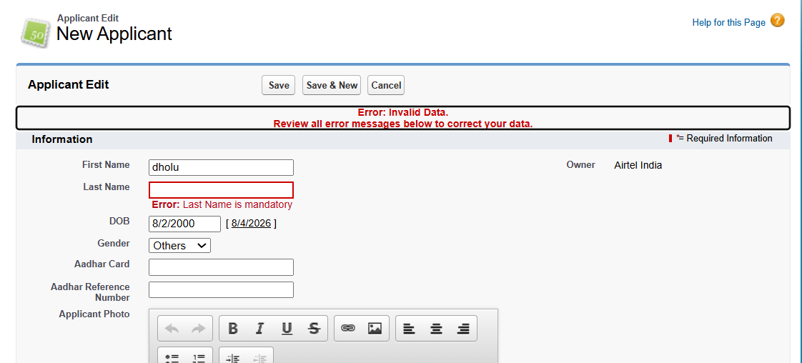

- Either from validation rule- using ISBLANK(last_name) to make it mandatory
Isempty is used for collection like list, set
, null for object is empty or not
Isblank used for string like last name.

- Or from field me “required”

Regex
Regular expression
Link to study more-
https://www.w3schools.com/js/js_regexp.asp
User story: prevent invalid pan card
Starting 5 are characters and then 6, 7, 8, 9 are numbers and 10 is again character.
Like – ABCDE6789F
All should be case insensitive as all are capital so abc and ABC are same.
NOT(ABCDE1234F) such that if it is true then show error msg, otherwise save it.
Steps
- CODE
NOT(
REGEX(
Pan_Card__c,
"[A-Za-z]{5}[0-9]{4}[A-Za-z]{1}"
)
)

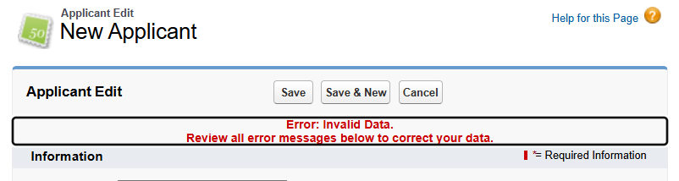
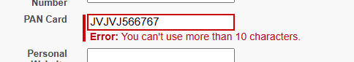

User story – 2
Prevent first name and last name invalid
- No special character
- No number

Code –
OR(
NOT(REGEX( First_Name__c , "^[A-Za-z]+$") ) ,
NOT(REGEX( Last_Name__c , "^[A-Za-z]+$")))

OR used as if any of them gets wrong it will show error
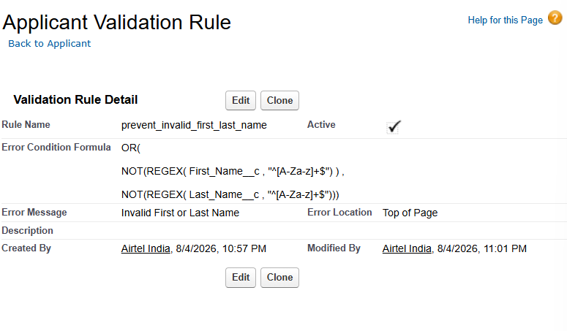
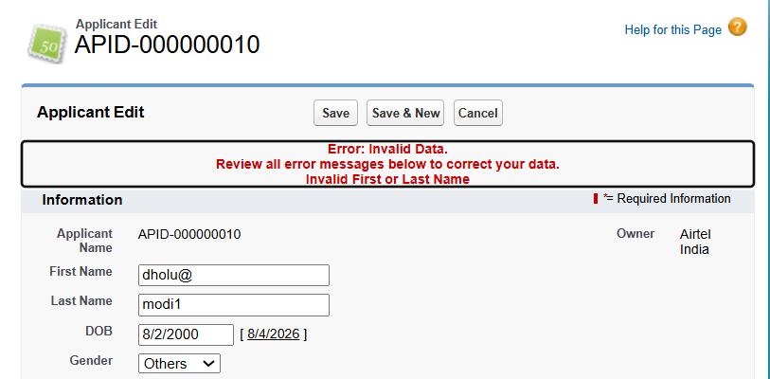

User story – 3
Prevent invalid email

AND(
NOT(ISBLANK(Email_ID__c)),
REGEX( Email_ID__c ,"[a-zA-Z0-9._%+-]+@[a-zA-Z.-]+\\\\.[a-zA-Z]")
)

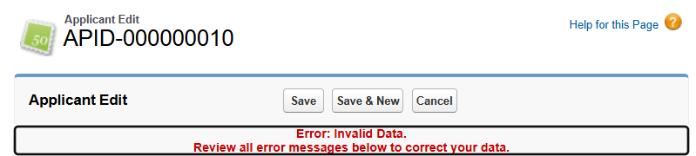
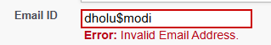
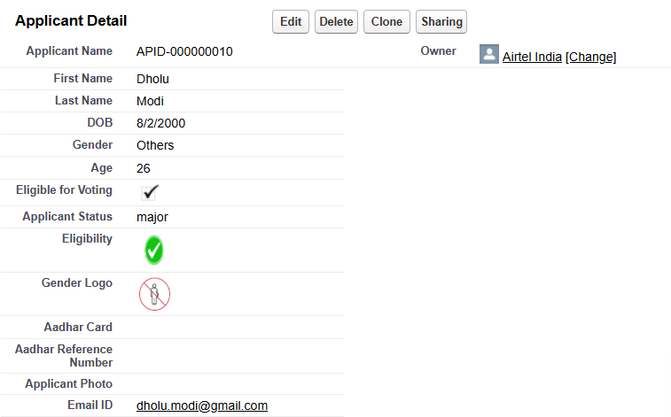


Assignment –
User & profile wise validation rules
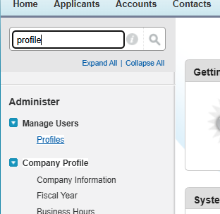
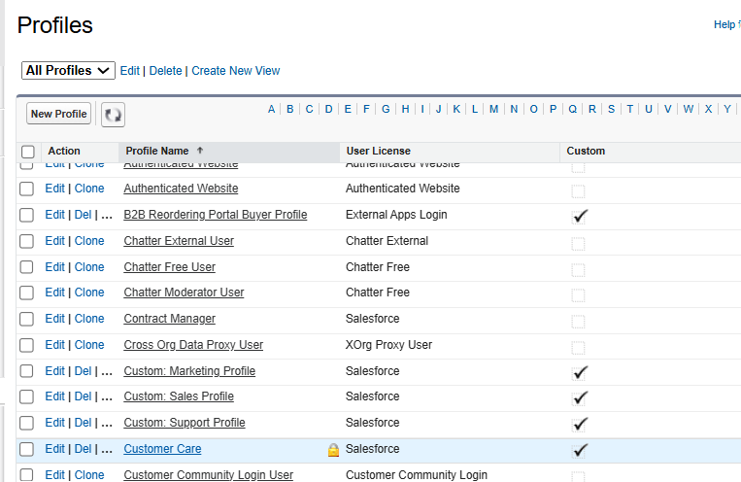
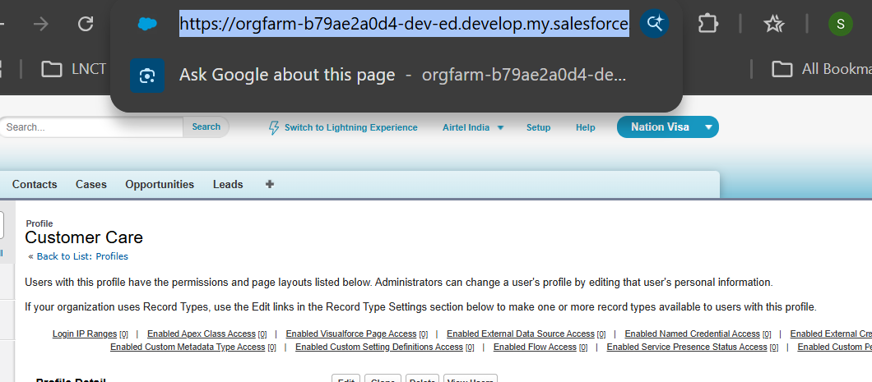

https://orgfarm-b79ae2a0d4-dev-ed.develop.my.salesforce.com/00ebm00000MRlB3
Id - 00ebm00000MRlB3
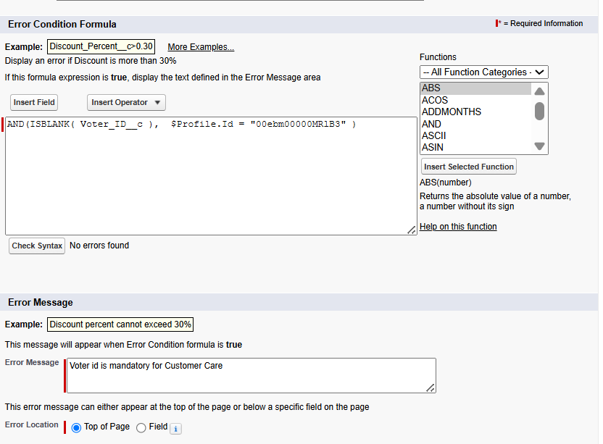

For user
Login in context with babli
Go
